**Day3**

name=input('enter name')  
  
print("name is ",name)

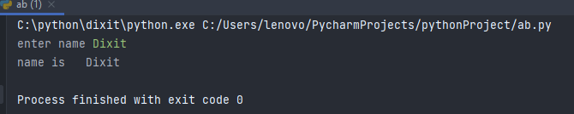

n1=int(input('enter num1:'))  
n2=int(input('enter num2:'))  
ans=n1+n2  
print("sum is",ans)

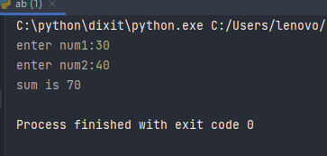

**Conditional statements**

n1=10  
n2=20  
if n1>n2:  
 print("n1 is gretest..")  
  
if n2>n1:  
 print("n2 is greater..")

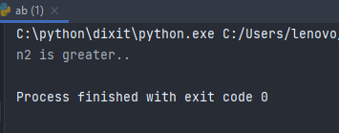

n1=10  
n2=20  
if n1>n2:  
 print("n1 is gretest..")  
  
else:  
 print("n2 is greater..")



n1=30  
n2=30 #100(output is n2 greater)  
if n1==n2:  
 print("both numbers are equals...")  
elif n1>n2:  
 print("n1 is greater")  
else:  
 print("n2 is greater")

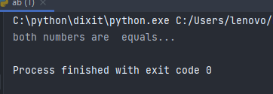

n1=10  
if n1>=0:  
 if n1==0:  
 print("n1 is zero..")  
  
 else:  
 print("n1 is positive..")  
   
else:  
 print("n1 is negitive..")

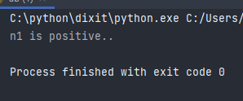

**LOOPS**

i=1  
while i<=10:  
 print("value is ",i)  
 i +=1

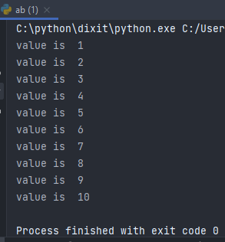

#for i in 'hello' :  
 #print("value is ",i)  
  
l1=[10,20,'hello']  
print(l1)  
  
for i in l1 :  
 print("value is ",i)

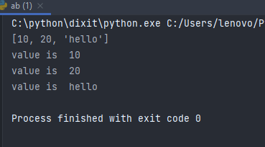

**Range functions**

#for i in range(10) :  
 #print("value is ",i)  
  
#for j in range(1,5):  
 #print("value is ",j)  
  
for k in range(1,10,3):  
 print("value is ",k)

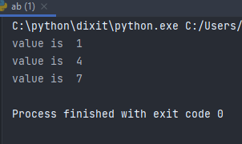

**Range function get collection value**

l1=[10,20,'hello']  
print(l1)  
  
for i in l1:  
 print("value is ",i)  
  
for j in range(len(l1)) :  
 print("value is ",l1[j])

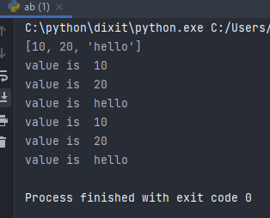

**Day 4**

**Functions in python**

**No argument No return type fn:-**

def myfunction():  
 print("hello world")  
  
myfunction()  
myfunction()

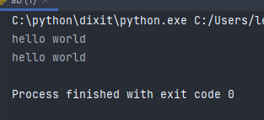

**Pass argument**

def myfunction(name):  
 print("hello world")  
 print("name is ",name)  
  
myfunction("dixit")

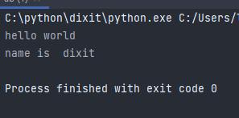

def myfunction(name):  
 print("hello world")  
 return name  
  
  
name=myfunction("dixit")  
print("value is ",name)

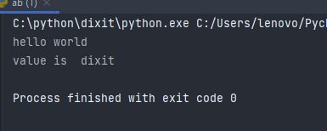

**Multiple value return**

def myfunction():  
 name="dixit"  
 n1=20  
 return name,n1  
  
name,n1=myfunction()  
print("name is",name)  
print("n1 is ",n1)

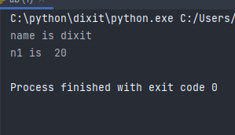

**Default argument**

def calsum(n1=150,n2=250):  
 print(n1+n2)  
  
calsum(20,30)  
  
calsum()

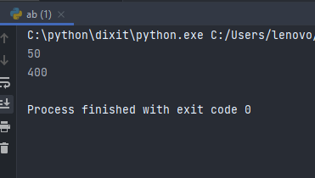

def calsum(n1,n2):  
 print(n1+n2)  
  
calsum(n2=20,n1=30) #keyword atgument

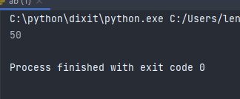

def sum(*n1):#variable length arg  
   
 sum=0  
  
 for i in n1:  
 sum=sum+i  
  
 print("ans is",sum)  
  
sum(10,30)  
sum(10,30,50)

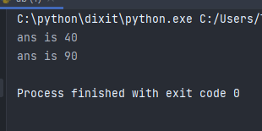

def myfunction(**arg):  
 for i,j in arg.items(): #keyword arg  
 print(i,j)  
  
   
  
myfunction(name='dixit',nm='hello')

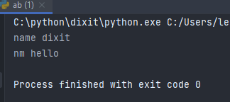



def myfunction(name):  
 print("this is my fn demo file...")  
 return name

